***Data Link Layer***

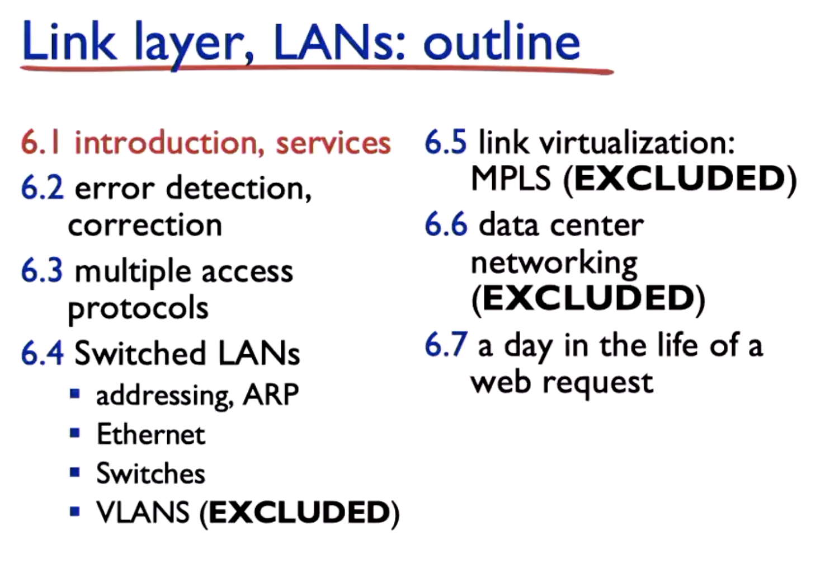

* 6.7 Will be important because it wraps up all the layers. The last question in finals is a wrap up on all layers

**Overview:**

* Link layer focuses within the subnet
* Responsibility of transferring datagram from one node to physically adjacent node over a link

**What the frame looks like**

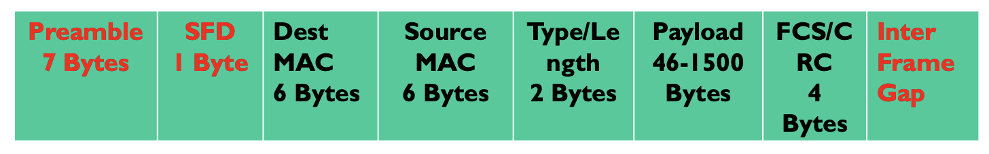

* Dest MAC Address
* Source Mac Address
* Type/Length
* Payload
  + Max size is MTU (1500 bytes)
* CRC
* Interframe gap is 12 bytes

Overhead is 18 bytes in total

* 6+6+2+6